
Presents

10 mile Summer Classic Time Trial incorporating the Essex TT Championships

Promoted for and on behalf of Cycling Time Trials under their Rules and Regulations

Saturday 30th July 2022
Course E91/10B - Start at 8:00

Event Headquarters: Leaden Roding Village Hall, Stortford Road, Leaden Roding, Essex, CM6 1QX. Open from 7:00

Event Organiser: Mr Paul Hart, Heath View, 32 Downham Road, Ramsden Heath, Essex, CM11 1PU
paul@hartperformancecoaching.com / 07528 681085

Timekeepers: Mr Trevor Pedley & Mr Ian Taylor

A HUGE thank you to our Event Sponsors





AWARDS

Essex Champions each receive £100 NoPinz Vouchers and opportunity to own Champions kit.

Junior Boy Essex TT Champion
Ladies Essex TT Champion
Men’s Essex TT Champion
Ladies Essex Road Bike TT Champion
Men’s Essex Road Bike TT Champion

Junior Boy:
1st: £30
2nd: £20
3rd: £10

Ladies TT:
1st: £30
2nd: £20
3rd: £10

Men’s TT:
1st: £30
2nd: £20
3rd: £10

Ladies Road Bike:
1st: £30
2nd: £20
3rd: £10

Mens Road Bike:
1st: £30
2nd: £20
3rd: £10

Prize Presentation: 10:30am in the Village Hall. Please stay and either collect your prize or congratulate the award winners.

Champions to have photo taken in Champions Jersey during presentation.

At HQ there will be free Tea/Coffee and amazing cakes @ £1 each. Please bring change!

Course Code: E91/10B

START at give way sign in Lane from High Easter just before the Four Wantz crossroads at Margaret Roding. Turn left on A1060 towards Chelmsford.
TURN at Beddells End Roundabout (5.4miles) and retrace to FINISH at a point 392 yards past Peppers Green sign, opposite wooden post 15yards before signpost to ‘The Easters’

Course map
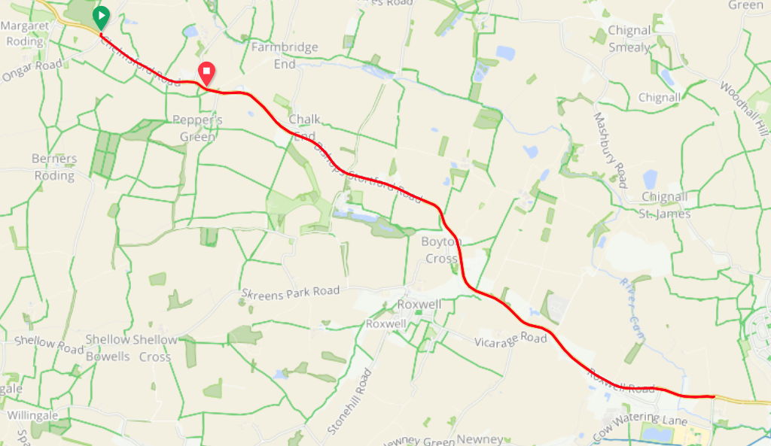

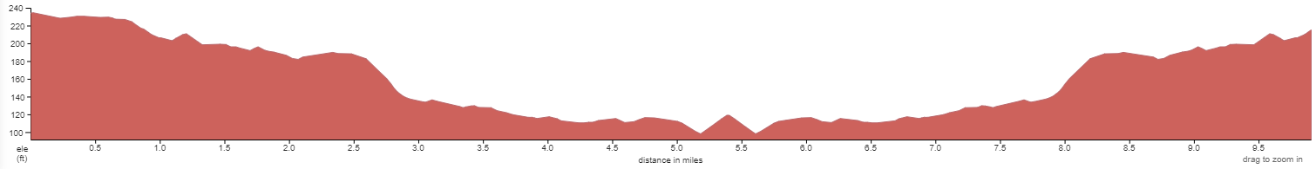

Strava: https://www.strava.com/segments/10246105?filter=overall

Course Records:
Ladies: Lara Thomas 24:26 (2022)
Mens: Alex Dowsett 19:06 (2010)
Junior: James Wicks 24:37 (2022)

Road Bike Records:
Ladies: Paulina Mozal 26:57 (2022)
Mens: Matthew Rivers 23:49 (2022)
Junior: Tom Womack (25:56)

HQ to start: 1.7 miles.
PLEASE ALLOW 10-15 MINS.
LEFT out of HQ to the mini roundabout. RIGHT onto the A1060 (Chelmsford Road).

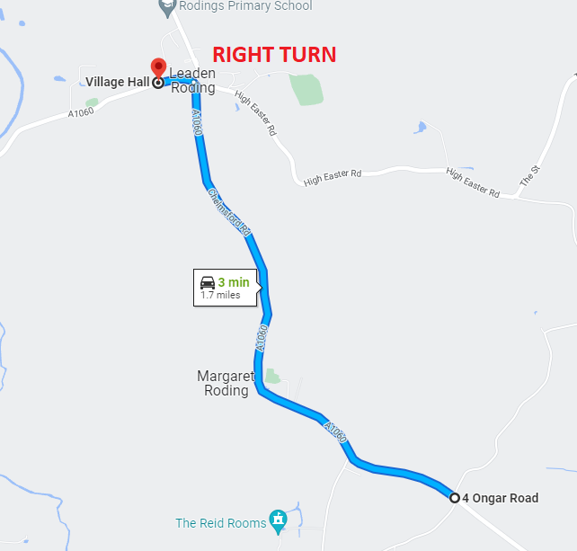

Finish to HQ: After finish, stay on A1060 to the Leaden Roding mini roundabout. LEFT at the roundabout, VH on your right hand side.

Reserve Course: We have the E91/10A booked as a reserve course in case of roadworks or any other unforeseen circumstance. This course runs from Aythrope Roding to Clapton Hall Lane and back.

Parking: The HQ has a generous car park including an overflow car park (on the field). Please park efficiently and considerately.

Additional Parking: If for some reason there isn’t enough room at HQ, there is a lay-by outside the Rodings Primary School in Leaden Roding (CM6 1PZ) which will accept approx. 30 cars. Please note no cars may park at the start or the finish, nor on the verges adjacent.

Sign In / Out. All competitors must sign in at HQ and collect their number. Once finish you must return your number to HQ and Sign out. If you do not sign out you will be DQ’d.

Lights: The use of FRONT and REAR lights whilst competing is MANDATORY. These lights must be switched on and working at the start of the event. No lights No ride.

Cycling helmets: Cycling Time Trials require ALL COMPETITORS wear a HARD-SHELL HELMET that meets an internationally accepted safety standard. No Helmet No ride.

Litter: Riders are reminded that dropping litter (such as energy gel wrappers) is a criminal offence and offenders will be liable to disciplinary action by the District Committee.

Warming up: In respect of consideration for local residents, the use of static trainers, e.g.. turbo trainers, is banned from all morning events held in the London East District. No warming up along the course by competitors once the event has started.

No ‘U’ Turns: are allowed within sight of either the start or finishing points. Riders carrying out this dangerous manoeuvre are liable for disqualification from the event and further disciplinary action by the District Committee.

Roundabout at mile 5.4: There is no prize for crashing. The roundabout is not the place to try and save 2 secs. Take your time, be aware of traffic. The road is not closed, there will be cars. You must follow the highway code.

Covid-19 Reminder: There will be pushing off at the start, and results at HQ like the good old times. Just a polite reminder that if you are experiencing any COVID like symptoms then please do not ride. Even if you have a negative test, riding full gas whilst unwell isn’t sensible.

Photographer: Annabelle May Photography will be taking photos before, during and after the time trial. Give a BIG smile if the camera comes near you. We aim to capture the friendly atmosphere of a typical local time trial to share with all those who did not enter (but hopefully will next time!)

Road Bike Prizes: There will be a marshal at the start who will check those who are riding road bikes are eligible. To clarify:
- No clip on TT bars
- No wheels over 90mm deep (including disc wheel)
- No aero helmet

Essex Time Trial Championship

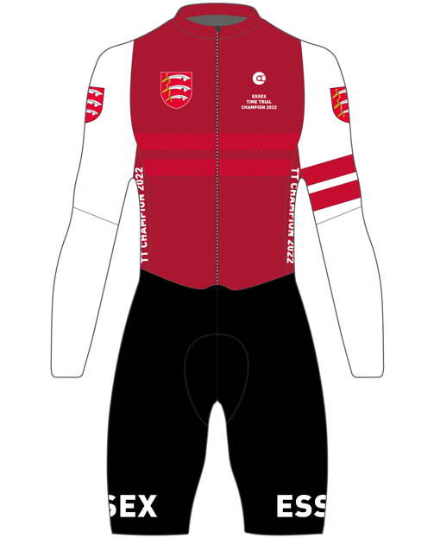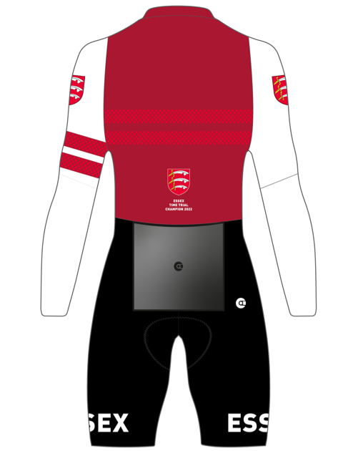

Champions Kit: NoPinz have designed an Essex Champions Skinsuit, Jersey, Shorts and Gilet. Skinsuit pictured above. These can be only ordered by the Champions. NoPinz have kindly donated vouchers as prizes to help with the purchases. CTT have approved the wearing of the Essex Champions kit at both club and open TT events.

Eligibility: Your registered address with CTT to be an Essex address. Those eligible for the Essex Championship listed below.

Note re kit usage: Only the current champions can wear the skinsuit in open time trials. If you lose the championship in 2023 you can no longer wear the skinsuit in open time trials. You can however wear the kit in club TT events or training for as many years as you wish.

Junior Champion: Fastest junior wins irrespective of road bike or TT bike.

- Junior Girl Essex TT Champion
- Junior Boy Essex TT Champion
- Ladies Essex TT Champion
- Men’s Essex TT Champion
- Ladies Essex Road Bike TT Champion
- Men’s Essex Road Bike TT Champion

Is this your first time trial?

We are delighted to have so many new time triallists at our event. Thank you to all of you that have entered. To help with that pre-race anxiety here are a few tips:

- Read the full start sheet. It will contain lots of important information.
- Aim to arrive at the HQ an hour before your start time. Being late increases stress. Park in the designated car park and you can change at the HQ.
- Sign on and collect your race number. Pin it down low on your back so it can be seen by the timekeepers. If you are under 18 you must have a signed parental form and hand it to the organiser or official when signing on.
- Ensure your bike is ready a few days before the event. You do not want to be making adjustments before the race. Its beneficial to be relaxed and calm before your race.
- Know how to get to the start. Maybe print a map. Also buddy up with someone in the car park who is starting at a similar time to you and ride to the start together. This will also help with pre-race nerves.
- Ensure you have your number pinned on, a working front and rear light and are wearing a helmet before you set off towards the start.
- The start is 1.7 miles from HQ. Use this ride as your warmup. Allow minimum 20-25 mins to relax and do a thorough warm up. Arrive at the start 5mins before your start time and wait. Remember No U turns in sight of the start or finish.
- Know the route. At 5.4 miles there is a small roundabout. Retrace that and ride back. Simple!
- Ride as fast (and safely) as you can. Take your time at the roundabout. That is not the place to try and save a few seconds. Be safe!
- If you see a photographer on the course, ensure you have a BIG smile!
- Once finished ride back to the HQ. Ensure you hand your race number back and sign out. To be featured in the results you must do this.
- When at the HQ have a cuppa and some cake and get your excuses ready for why you didn’t win!
- Start to plan how you will go faster next time.

HPC Partners






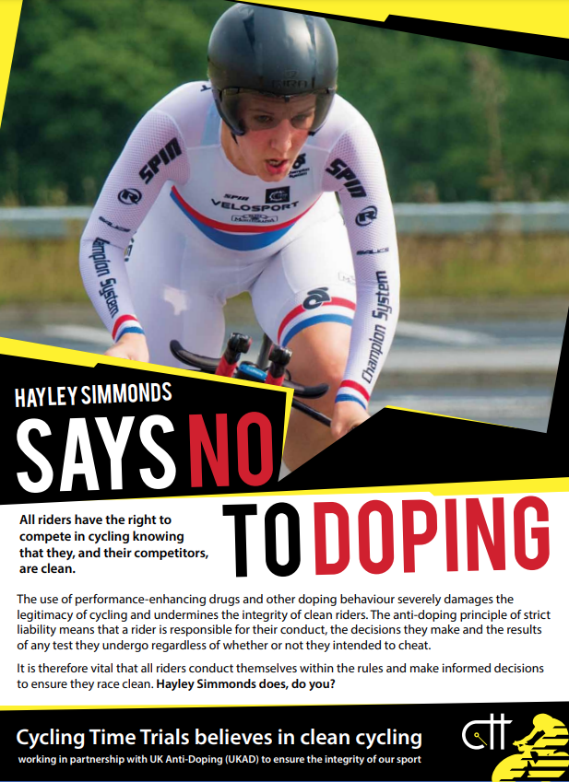

bib | start_time | firstname | lastname | club | Essex
 |  |  |  |  | Qualifying
 | Mens RB
4 | 08:04:00 | David | Jacobs | Southend Wheelers | Y
5 | 08:05:00 | Martin | Meades | Ciclos Uno | Y
6 | 08:06:00 | Adam | Jones | Southend Wheelers | Y
7 | 08:07:00 | Andrew | Whelan | Velo Schils Interbike RT | Y
8 | 08:08:00 | Chris | Dunn | Maldon & District CC | Y
9 | 08:09:00 | Werner | Kriek | East London Velo | N
10 | 08:10:00 | Aaron | Green | Shaftesbury CC | Y
11 | 08:11:00 | Vincent | Christan | East London Velo | Y
12 | 08:12:00 | Aidan | Kerrigan | Lee Valley Youth CC | Y
13 | 08:13:00 | Rob | Chaplin | East London Velo | Y
14 | 08:14:00 | David | Glossy | Bicester Millennium CC | N
15 | 08:15:00 | Max | Eagle | OVB | Y
16 | 08:16:00 | Daniel | Lord | University of Warwick | Y
17 | 08:17:00 | Louis | Digance | Hart Performance Coaching | Y
18 | 08:18:00 | Paul | Turton | Team Vision Racing - Silverhook | Y
19 | 08:19:00 | Thomas | Willan | East London Velo | Y
20 | 08:20:00 | Matthew | Lord | Hart Performance Coaching | Y
21 | 08:21:00 | Jonny | Allen | 6AM Cycling | N
 | Ladies RB
24 | 08:24:00 | Marion | Denby | West Suffolk Wheelers | N
25 | 08:25:00 | Leah | Brook | Shaftesbury CC | Y
26 | 08:26:00 | Camilla | Wilkes | Hart Performance Coaching | Y
 | Juniors
29 | 08:29:00 | Tom | Womack | Southend Wheelers | Y
30 | 08:30:00 | Will | Barham | Hart Performance Coaching | Y
31 | 08:31:00 | Henry | Hill | Lee Valley Youth CC | Y
32 | 08:32:00 | Antoine | Rouyer-Brown | Inflite | Y
33 | 08:33:00 | Morgan | Saunders | Team Vision Racing - Silverhook | Y
34 | 08:34:00 | James | Wicks | Essex Roads CC | Y
35 | 08:35:00 | Brandon | Baldacci | Lee Valley Youth CC | Y
 | Ladies TT
38 | 08:38:00 | Courtney | Granger | Athlon CC | Y
39 | 08:39:00 | Brady | Ramsay | Team Vision Racing - Silverhook | Y
40 | 08:40:00 | Emma | Haxell | Athlon CC | Y
41 | 08:41:00 | Jan | Harvey | Southend Wheelers | Y
42 | 08:42:00 | Joanna | Butcher | CC Sudbury | Y
43 | 08:43:00 | Ann | Shuttleworth | Cambridge CC | Y
44 | 08:44:00 | Isabella | Torrie | Datalynx-Parenesis Cycling | Y
45 | 08:45:00 | Julia | Freeman | Easterley Road Club | Y
46 | 08:46:00 | Karen | Aylen | Maldon & District CC | Y
47 | 08:47:00 | Louise | Robinson | Essex Roads CC | Y
 | Mens TT
50 | 08:50:00 | Sam | Wightman | Team Bottrill | Y
51 | 08:51:00 | Ian | Short | Team Salesengine.co.uk | N
52 | 08:52:00 | Luca | Morrone | Regents Park Rouleurs | N
53 | 08:53:00 | Alexander | Fox | Essex Roads CC | Y
54 | 08:54:00 | Viktor | Taranenko | London Baroudeurs Cycling Club | N
55 | 08:55:00 | James | Bromley | Hart Performance Coaching | Y
56 | 08:56:00 | Chris | Smith | Essex Roads CC | Y
57 | 08:57:00 | Jon | Hughes | Sheppey Velo | Y
58 | 08:58:00 | Stuart | Mulchinock | Southend Wheelers | Y
59 | 08:59:00 | Paul | Russell | East London Velo | Y
60 | 09:00:00 | Bradley | Hurr | Basildon CC | Y
61 | 09:01:00 | Phil | Bailey | Loose Cannon's Conditioning | N
62 | 09:02:00 | Carl | Bond | Kenton RC | N
63 | 09:03:00 | Geoff | Bores | Ford CC | Y
64 | 09:04:00 | Philip | Hodey | Shaftesbury CC | Y
65 | 09:05:00 | Peter | Tibbitts | Ford CC | N
66 | 09:06:00 | Andrew | Merchant | Southend Wheelers | Y
67 | 09:07:00 | Dominic | Schils | Velo Schils Interbike RT | Y
68 | 09:08:00 | Andrew | Wenham | Shaftesbury CC | Y
69 | 09:09:00 | Joe | Kerner | trainSharp Development Team | Y
70 | 09:10:00 | Adrian | Tovey | Maldon & District CC | Y
71 | 09:11:00 | Dan | Walsh | Southend Wheelers | Y
72 | 09:12:00 | Richard | Mellor | Team Bottrill | Y
73 | 09:13:00 | John | Iszatt | Team Vision Racing - Silverhook | Y
74 | 09:14:00 | Richard | Knight | CC London | N
75 | 09:15:00 | Richard | Parrotte | Shaftesbury CC | Y
76 | 09:16:00 | Dan | Whitehouse-Smith | VØRANJE | N
77 | 09:17:00 | Ben | Love | Pirate juice cc | N
78 | 09:18:00 | Alex | Warburton | Velo Schils Interbike RT | Y
79 | 09:19:00 | Antony | Stapleton | North Essex Velo | Y
80 | 09:20:00 | Stephen | Murphy | Shaftesbury CC | Y
81 | 09:21:00 | Joshua | Granger | Athlon CC | Y
82 | 09:22:00 | Ian | Cardy | Chelmer CC | Y
83 | 09:23:00 | Murat | Ozdenya | Team Vision Racing - Silverhook | N
84 | 09:24:00 | James | Moss | North Road CC | N
85 | 09:25:00 | Dan | Jenkins | Southend Wheelers | Y
86 | 09:26:00 | Richard | O'Rourke | Team Vision Racing - Silverhook | Y
87 | 09:27:00 | Neil | Hughes | Velo Schils Interbike RT | Y
88 | 09:28:00 | Matthew | Saunders | Team Vision Racing - Silverhook | Y
89 | 09:29:00 | Terry | Garlinge | Easterley Road Club | Y
90 | 09:30:00 | Keith | Dorling | Team Bottrill | Y
91 | 09:31:00 | Henry | Okill | Southend Wheelers | Y
92 | 09:32:00 | Sean | O'Sullivan | Hart Performance Coaching | Y
93 | 09:33:00 | David | Harding | Chelmer CC | Y
94 | 09:34:00 | Lee | Turner | Arctic Aircon RT | N
95 | 09:35:00 | Samuel | Thienel | Hart Performance Coaching | Y
96 | 09:36:00 | Simon | Alexander | Richardsons-Trek RT | Y
97 | 09:37:00 | Timothy | Torrie | trainSharp Development Team | Y
98 | 09:38:00 | Colin | Ward | Essex Roads CC | Y
99 | 09:39:00 | Ian | Hope | Team Ohten Aveas | Y
100 | 09:40:00 | James | Jenkins | Richardsons-Trek RT | Y

